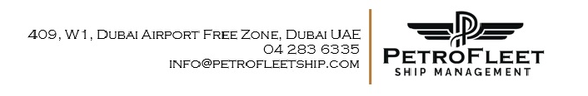
VESSEL PARTICULARS
MT SEA CITRINE VI
Port of Registry | PANAMA
Flag | PANAMA
Call Sign | 3FSB4
E-Mail / phone number (s) | master.seacitrine6@gtmailplus.com +870 773272355
Inmarsat C | 435763311 - 435763312
MMSI | 357633000
IMO & Official Number | 9207273 / 51494
Build Year / Keel Laid | 1999 / 30-06-1998
Class/ Class no | DNVGL
ECDIS | Transas Navi Sailor 4000 ECDIS
Class Notation | NK / NS (Tob)(ESP), MNS*
Type of Vessel | Oil / Product Tanker
Gross tonnage | 7678.00 MT
Net Tonnage | 3852.00 MT
LOA x LBP x BREADTH x DEPTH | 125.7 x 118.91 x 21.5 x 11.0 Meters
Air Draft | 36.0 m (Normal ballast condition)
Light ship | 3553.19 MT
Bridge to Centre Manifold | 43.10 m
Bow to Centre Manifold | 59.10 m
Stern to Centre Manifold | 66.60 m
Build yard | Sasaki Shipbuilding Co. Ltd, Japan
Summer displacement | 16185.80 MT
Deadweight / Deadweight Draft | 12633 MT / 8.00 m
Suez Canal GRT / NRT | N/A
Anchors | Port Anchor Chain: 9 Shackles, STBD Anchor chain 10 Shackles
Main Engine – maker and type | Hanshin B&W 6S35MC
Main engine power | 4192 kw (5700 PS) x 170 rpm
Bow Thruster | N/A
Auxiliary engines | Yanmar / 6S165L-UN, 353 KW x 1200 RPM x 3 sets
Boiler | Miurra VWK - 1622-600/600
Cargo handling equipment’s | Mar flex Electric Deep well Pumps
Cargo Pump Capacity | Cargo: 12 x 400 m³/HR/ Slop: 2 x 150 m³/Hr.
Cargo tank type | Coated- Phenol Epoxy
Tank Capacity | 98% COT=13693.17 m³ – Slop’s P/S 98%= 423.36 m³
Tank Temperatures | N/A
PV Setting | +1400 mm WG, -350 mm WG
N2 Plant | N/A
Fuel Tank Capacity – HFO / MDO | 526.01 m³ / 113.61 m³ ⁽100%)
Fresh water capacity | 380 m³
Ballast water treatment system | N/A
Owner | WILSON SHIPPING INC
Manager | Anwar Al Furat Petroleum Product TR.LLC  Office 606, Al Buhairah Tower, 3 Corniche Road, Buhayrah , UNITED ARAB EMIRATES

