PORT OF CALL LIST

 |  |  |  | Arrival |  | Departure |  | Page No.1
 |  |  | √ | Arrival |  |  |  | Page No.1
- Name of ship  - IMO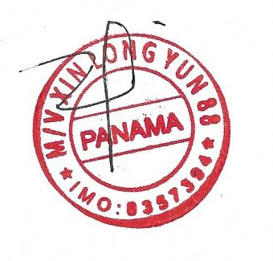 No.  1.3 Call Sign | BAI LI 3  8357394  3E8697 |  | 2. Port of Arrival / Departure |  |  |  | 3. Date of Arrival / Departure
4. Nationality of ship  PANAMA |  |  | 5. Port arrived from / next port of destination
6. Number of persons on board  17 |  | 7. Period of stay  DAY

IMO Convention on Facilitation of International Maritime Traffic | No. | Ports of Call | Arrival | Departure | Security Level | Remark
 | 1 | PORT KLANG, MY | 25-08-2025 | 25-08-2025 | LEVEL 1 | LOADING/BUNKERING
 | 2 | JEDDAH.SA | 16-09-2025 | 17-09-2025 | LEVEL 1 | LOADING/DISCHARGING
 | 3 | SOKHNA.EYGPT | 21-09-2025 | 21-09-2025 | LEVEL 1 | LOADING/DISCHARGING
 | 4 | AQABA,JORDAN | 25-09-2025 | 25-09-2025 | LEVEL 1 | LOADING/DISCHARGING
 | 5 | ALEXANDIRA,EYGPT | 29-09-2025 | 30-09-2025 | LEVEL 1 | LOADING/DISCHARGING
 | 6 | BENGHAZI,LIBYA | 04-10-2025 | 04-10-2025 | LEVEL 1 | DISCHARGING
 | 7 | ALGIERS,ALGERIA | 11-10-2025 | 14-10-2025 | LEVEL 1 | LOADING/DISCHARGING
 | 8 | MALTA,MALTA | 17-10-2025 | 17-10-2025 | LEVEL 1 | BUNKER
 | 9 | DAMIETTA,EGYPT | 22-10-2025 | 22-10-2025 | LEVEL 1 | LOADING
 | 10 | SOKHNA,EGYPT | 24-10-2025 | 24-10-2025 | LEVEL 1 | LOADING
 | 11 | AQABA,JORDAN | 26-10-2025 | 26-10-2025 | LEVEL 1 | LOADING
 | 12 | JEDDAH,SA |  |  |  | LOADING

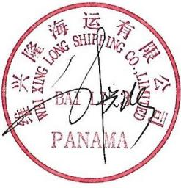
signature by master

MASTER :LIU XINGQIANG

